Brake Performance Control Function – CGEA1.3

Functional Description

The purpose of the Brake Performance Control function is to record distance traveled to bring the car to a complete stop from pre-selected speed thresholds, which are similar to the results that a drag strip would provide at the end of a run. The Brake Performance Control function is an application that is located under the Track Apps Menu. The function records Time and g-force for the standard performance tests listed below:

For US units:
- 60-0 MPH
- 100-0 MPH
For Metric units:
- 100-0 km/h
- 200-0 km/h

The user will have a choice of selecting any or all of the end points for data acquisition. Once a test point is selected, the user will be asked to accelerate until the vehicle reaches a start point. Once that is achieved, the instrument cluster will instruct the user to apply the brakes with a message on the cluster and a tone. Once the brakes are applied and the vehicle has slowed to the start speed, the timer will calculate distance, peak deceleration and time until the vehicle is stopped. The instrument cluster will attempt to collect timer information for as many of the brake functions that the selected endpoint will allow. The remaining timers will not be collected and will display blank.

At the end of the test, the result of the last run test criteria will get displayed. Once the vehicle is brought to a stop, the user will have the option of viewing the complete results, compare last run data with data from previously saved ones, and view all time results as well. The user will then also have the capability to save any results he wants from the last run data results.

The Track Applications Results Display function has 3 sets of data stored:

- Last run data: This data is stored at the successful completion of a brake performance run. This entire set of data is overwritten at the next run. If any values are not completed in a run, the values will be blank. The last run data should be retained until the next run overwrites the data or until the customer clears the saved and last run data.
- Saved Data: The user can elect to save any of the last run data. Saved data is not overwritten on the next successful run. Saved data shall remain in the cluster memory unless it is overwritten by the customer or cleared using the “Clear Saved” selection from the menu.
- All Time Best Data: This data is automatically collected out of the last run data. If the current All Time Best Data is worse than the last run data, the last run data is stored as the All Time Best Data. Each metric is handled and saved separately. This data can only be deleted by using the “Clear All Time Best” data from the menu.

The View/Clear results screens are only available when the vehicle is in stationary position (not moving). If the vehicle speed exceeds 8 KPH while the cluster is displaying the results screen, the cluster shall return to the Track Apps Menu selection screen.

The Brake Data acquisition function is only available with key in the Run/Start position. The Brake Performance feature is not available with MyKey.

The Brake Performance Control Function correlates the VehOverGnd_V_Est , VehLongComp_A_Actl and VehLatComp_A_Actl HS-CAN signals from the ABS_ESC, the BpedDrvAppl_D_Actl signal and the Operational mode to process the timer function.

Interfaces

Interface Context Diagram (I/O Block Diagram)
Figure 1.0 Brake Performance Control Function Context Diagram
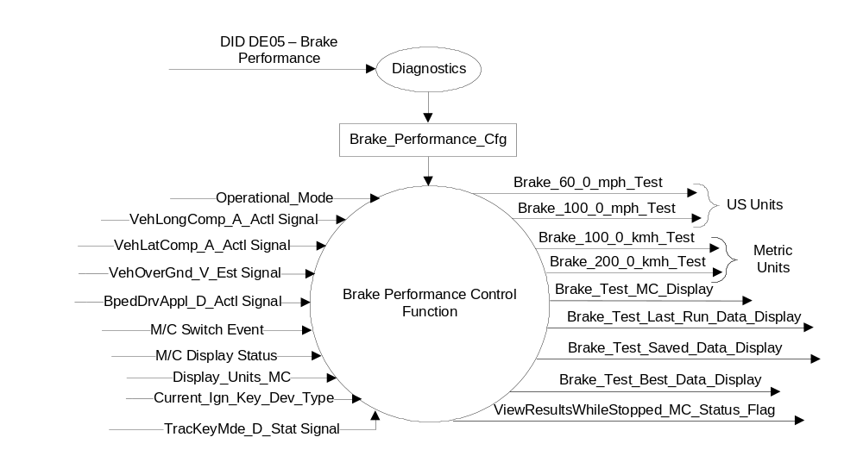

Inputs
- INTERNAL:
  - Operational_Mode: Refer to section Operational Modes
  - Current_Ign_Key_Dev_Type: Used to indicate the type of key currently in use in the vehicle. See MyKey Control Function SPSS for further definition
  - Brake_Performance_Cfg
  - M/C Display Status
  - M/C Switch Event
  - Display_Units_MC - Refer to the Display Unit Selection Control Function – CGEA1.3 STSS for more information.
- MUX messages on the HS_CAN Bus

- VehLongComp_A_Actl Signal
Signal Name | Size (bits) | Detail | Units | Res. | Offset | State Encoded | Min | Max
VehLongComp_A_Actl | 10 |  | m/s^2 | 0.035 | -17.9 |  | -17.9 (0x0) | 17.835 (0x3FD)
 |  | Unknown |  |  |  | 0x3FE
 |  | Fault |  |  |  | 0x3FF

- VehLatComp_A_Actl Signal
Signal Name | Size (bits) | Detail | Units | Res. | Offset | State Encoded | Min | Max
VehLatComp_A_Actl | 10 |  | m/s^2 | 0.035 | -17.9 |  | -17.9 (0x0) | 17.835 (0x3FD)
 |  | Unknown |  |  |  | 0x3FE
 |  | Fault |  |  |  | 0x3FF

- VehOverGnd_V_Est Signal
Signal Name | Size (bits) | Detail | Units | Res. | Offset | State Encoded | Min | Max
VehOverGnd_V_Est | 10 |  | kph | 0.01 | 0 |  | 0 (0x0) | 655.33 (0xFFFD)
 |  | Unknown |  |  |  | 0xFFFE
 |  | Fault |  |  |  | 0xFFFF

- BpedDrvAppl_D_Actl Signal
Signal Name | Size (bits) | Detail | Units | Res. | Offset | State Encoded | Min | Max
BpedDrvAppl_D_Actl | 2 |  | SED | 1 | 0 |  | 0 (0x0) | 3 (0x3)
 |  | Not_Allowed |  |  |  | 0x0
 |  | Driver_Not_Braking |  |  |  | 0x1
 |  | Driver_Braking |  |  |  | 0x2
 |  | _Not_Allowed |  |  |  | 0x3

- TracKeyMde_D_Stat Signal
Signal Name | Size (bits) | Detail | Units | Res. | Offset | State Encoded | Min | Max
TracKeyMde_D_Stat | 2 |  | SED | 1 | 0 |  | 0  (0x0) | 3  (0x3)
 |  | ModeNotDetermined |  |  |  | 0x0
 |  | Active |  |  |  | 0x1
 |  | NotActive |  |  |  | 0x2
 |  | NotUsed |  |  |  | 0x3

Outputs
- Brake_Test_MC_Display
- Brake_Test_Last_Run_Data_Display
- Brake_Test_Saved_Data_Display
- Brake_Test_Best_Data_Display
- ViewResultsWhileStopped_MC_Status_Flag

- Brake_60_0_mph_Test
- Brake_100_0_mph_Test

- Brake_100_0_kmh_Test
- Brake_200_0_kmh_Test

Function/Performance

Operational Modes

Mode | Differentiating Vehicle Conditions
Sleep Mode | Brake Performance Test Display messages Inactive
Limited Mode | Brake Performance Test Display messages Inactive
Normal Mode | Brake Performance Test Display messages Active / Inactive
Crank Mode | Brake Performance Test Display messages Active / Inactive

Voltage Levels

Refer to Cluster Features table located in the Operational Modes and Voltage Range Strategies section in this SPSS.

Human-Machine Interface

Visual

Indicator Graphics / Display Format
Example graphics (not all graphics are shown here):

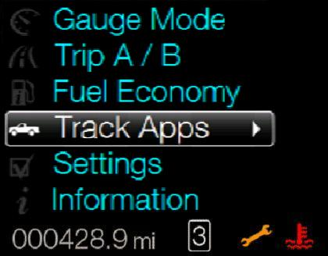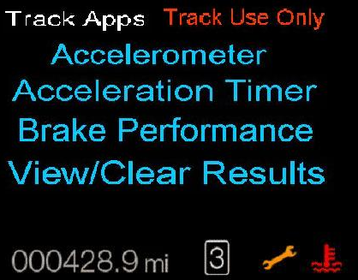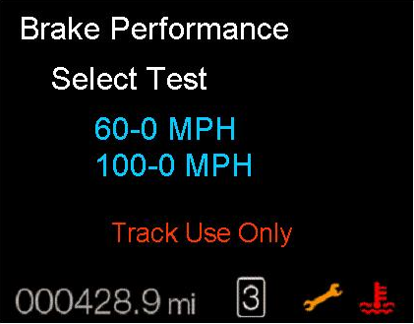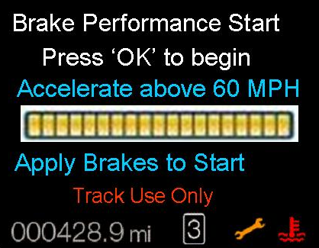
1 2 3 4

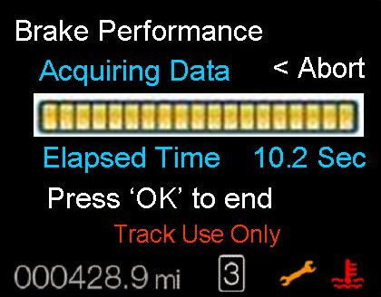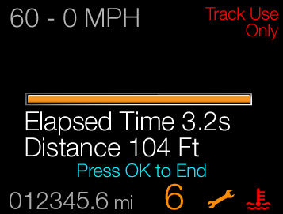
5 6

Indicator Color Coordinates

Indicator Characteristics

Audio

None

Switch Control Logic

Not applicable.

System Accuracy

- The Brake performance results shall be displayed in the format of XX.X seconds, YYY.Y (Feet for English units, meters for Metric units) and Z.ZZ G.
Test End Points:
- 60-0 mph: The data acquisition shall start when the vehicle speed reaches 96.56 KPH and stop when vehicle speed reaches 0 kph
- 100-0 mph: The data acquisition shall start when the vehicle speed reaches 160.9 KPH and stop when vehicle speed reaches 0 kph.

Operation: Performance and Functional

Subsystem Algorithm Flowchart / State Diagram
Figure 1.1 Brake Performance Selection Criteria
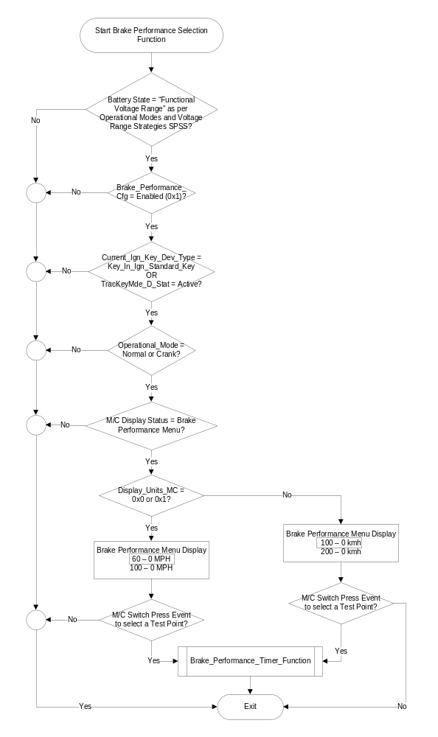
Figure 1.2 Brake_Performance_Timer_Function Subroutine
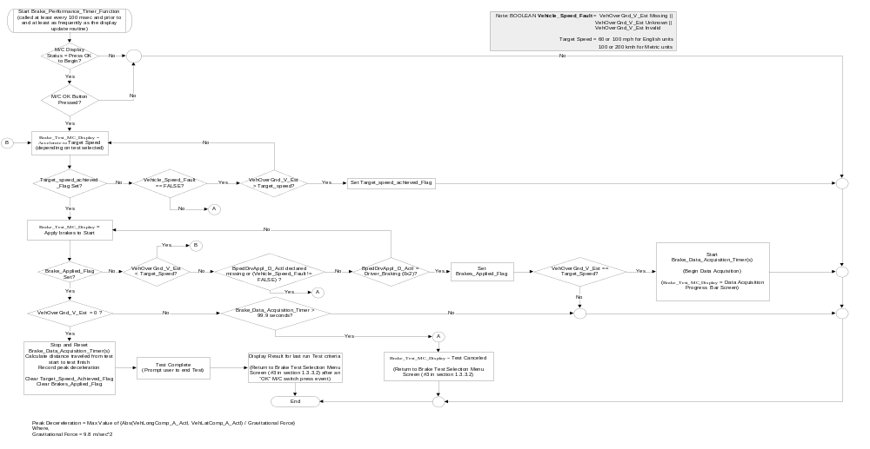

View/Clear Results Display Menu
There are 3 sets of data stored for the brake performance feature:

- Last run data: This data is stored at the successful completion of track feature run. This entire set of data is overwritten at the next run. If any values are not completed in a run, the values will be blank. The last run data should be retained until the next run overwrites the data or until the user clears the saved and last run data. The last run data shall be retained over ignition cycles until over written by next successful run or cleared by the user.
- Saved Data: The user can elect to save any of the last run data. Saved data is not overwritten on the next successful run. Saved data shall remain in the cluster memory unless it is overwritten by the user or cleared using the “Clear Saved” selection from the menu.
- All Time Best Data: This data shall be collected out of the last run data. If the current All Time Best Data is worse than the last run data, the last run data is stored as the All Time Best Data. Each metric is handled and saved separately. This data can only be deleted by using the “Clear All Time Best” data from the menu.

Figure 1.3 View/Save Results Display Function

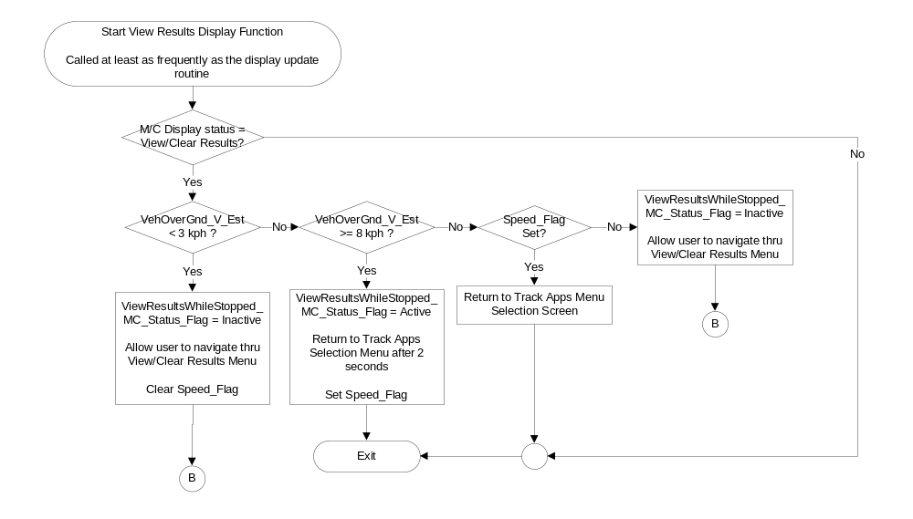
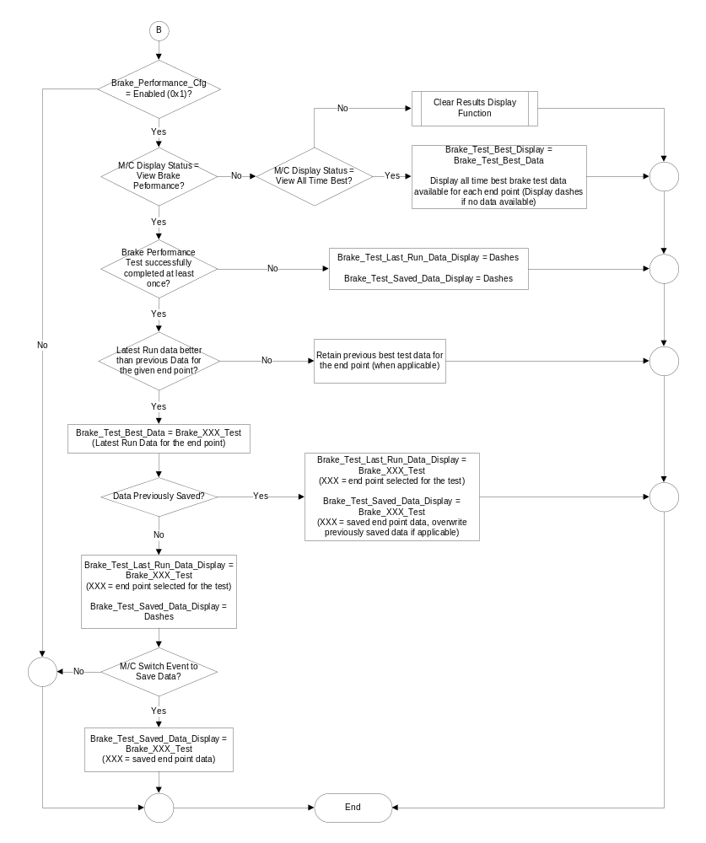

Figure 1.4 Clear Results Display Function
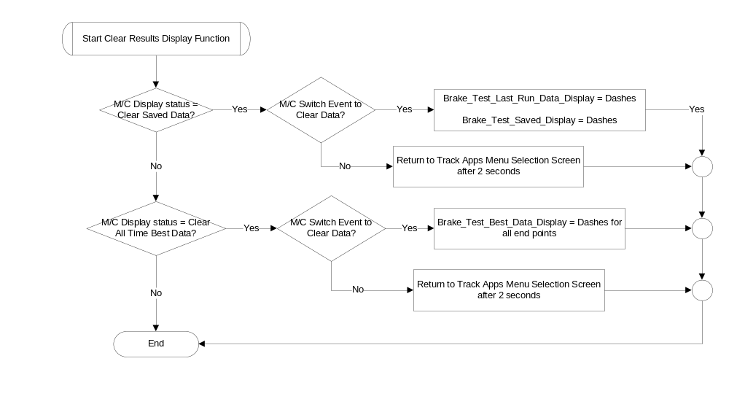

Operation Description (supports algorithm flowchart /state diagram)

- View/Clear Results while Stopped Status Flag to Display Mapping

ViewResultsWhileStopped_  MC_Status_Flag | MC Message ID
Active | W3263

- All the screens under the Brake Performance menu shall display “Track Use Only” on the screen at all times.
- The Brake_Data_Acquisition_Timer is defined as 1 timer. However, supplier may use as many timers as required to record data for the selected Test end points.
- The cluster may use the odometer function or the following formula to calculate distance traveled:
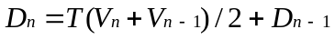
Where
V_{n} = Current Vehicle Speed based on VehOverGnd_V_Est
T = Periodic rate of the CAN message
D_{n} = Current distance traveled
- Distance measured for Brake Performance test in English units shall be in units of feet and in units of meters for test performed in Metric units.

- A direct form 1 filter shall be applied to the input signals as follows to get an accurate accelerometer value displayed:

a[1] * y[n] = ( b[1] * x[n] ) + ( b[2] * x[n-1] ) + ( b[3] * x[n-2] ) - ( a[2] * y[n-1] ) - ( a[3] * y[n-2] ) Where,
a = denominator coefficients
b = numerator coefficients
x(n) = Unfiltered signal - VehLongComp_A_Actl or VehLatComp_A_Actl
y(n) = filtered signal - VehLongComp_A_Actl or VehLatComp_A_Actl
Once the values are generated after applying the filter, a roll (for lateral movement) and pitch (for longitudinal movement) correction multiplier is then applied to get the final data.
The coefficient constants and multiplier are program dependent, hence, are provided directly by the program based on track tests and other factors.

The running filer is applied once 3 values of the valid unfiltered signal are received.
The filter may be applied at the same rate the display update function.

- The cluster shall display a status bar of the test completion similar to screen 5 in section 1.3.3.2 indicating how close to the target the customer is. The “Elapsed Time” is not dynamic, however, it shall display the time taken once the test criteria has been successfully completed.
- If the vehicle does not reach 0 KPH during the Data Acquisition period and the brake timer exceeds 99.9 seconds, the test shall be considered canceled, no results will be recorded. The cluster shall return to the Brake performance test point menu selection screen.
- At any given time during the Data Acquisition process if any of the signal is declared missing, invalid or unknown, the test shall be stopped and considered canceled and no results will be recorded for that test until a test is deemed successfully complete.
- It is not required to display the progress bar (example: screen 4) while vehicle is accelerating to reach target speed. All screens shown in section 1.3.3.2 are for example purposes only and may be changed as required per program needs.
- The cluster shall clear all available “All Time Best” data when the option to “Clear All Time Best” is selected by the user.
- The cluster shall clear all available “Last Run Data” and “Saved Data” when the option to “Clear Saved Data” is selected by the user.
- The Brake Performance feature shall not be available if Brake_Performance_Cfg is set to disabled (0x0).
- The Brake Performance feature shall not be available if the vehicle is driven using My Key.
- Anytime the user actively engages the adaptive cruise control (CC_Function_Display = ACC_CRUISE (0x3), ACC_FOLLOW (0x4), ACC_OVERRIDE (0x5), SGACC_STOP_NLV (0x9), SGACC_STOP_LV (0xA) OR SGACC_RES_READY (0xB)), the cluster shall display “Test Canceled”, stop all brake performance functionality and return to the main menu. No data shall be collected for any incomplete performance tests.

Function Safety Classification (EMC)

Class B

Memory Storage
Parameter Name | Description | Value at Battery Connect | Value at Module Wake-up
VehLongComp_A_Actl Signal | Input longitudinal acceleration sent from the ABS_ESC. | -17.9 m/s^2 (0x0) | -17.9 m/s^2 (0x0)
VehLatComp_A_Actl Signal | Input latitudinal acceleration values sent from the ABS_ESC. | -17.9 m/s^2 (0x0) | -17.9 m/s^2 (0x0)
VehOverGnd_V_Est Signal | Vehicle speed input from ABS_ESC. | 0 kph (0x0) | 0 kph (0x0)
BpedDrvAppl_D_Actl Signal | CAN Input from ABS. | Not_Allowed (0x0) | Not_Allowed (0x0)
TracKeyMde_D_Stat signal | Input from BCM providing status of TracKey | ModeNotDetermined (0x0) | ModeNotDetermined  (0x0)
English Units:  Brake_60_0_mph_Test  Brake_100_0_mph_ Test  Metric Units:  Brake_100_0_kmh_Test  Brake_200_0_kmh_ Test | Array of output variables that hold data for brake performance tests. | 00.0 sec  000.0 ft or m  0.00 G | 00.0 sec  000.0 ft or m  0.00 G
Brake_Test_MC_Display | Different text messages displayed during various states of the brake performance test. | Inactive | Inactive
Brake_Test_Last_Run_Data_Display | Results display of the brake test end points. | Dashes | Dashes
Brake_Test_Saved_Data_  Display | User saved brake performance data for all test points. | Dashes | Do Not Init
Brake_Test_Best_Data_  Display | All Time best data for brake performance end points | Use stored value | Use stored value
ViewResultsWhileStopped_  MC_Status_Flag | Used to control the state of the display for the Message Center arbitrator | Inactive | Inactive
Brake_Performance_Cfg | State indicator for feature presence controlled via CAN at EOL at VO plant. Set to Disabled at Cluster Supplier Manufacturing Plant | Use Stored Value | Use Stored Value
Operational_Mode | 4 state indicator for cluster operational mode | Limited | Limited or Normal or Crank

Parameter Name | Description | Range | Units | Res | Init Value
Brake_Data_Acquisition_Timer(s) | Timer(s) to keep track of brake tests | 0-99.9 | sec | 0.1 | 0

Prove Out

No

Error Handling

Missing Message Strategy

The signals will be declared missing as per the Diagnostics section of this SPSS.

DTCs states and history will be determined as per the Diagnostics section of this SPSS.

If Brake_Performance_Cfg = Disabled, the cluster shall never log a missing message DTC due to this feature.

Invalid Message Strategy

The signal data will be declared invalid as per the Diagnostics section of this SPSS.

DTCs states and history will be determined as per the Diagnostics section of this SPSS.

If Brake_Performance_Cfg = Disabled, the cluster shall never log an invalid data DTC due to this feature.

Unknown Message Strategy

The signal data will be declared unknown as per the Diagnostics section of this SPSS.

DTCs states and history will be determined as per the Diagnostics section of this SPSS.

If Brake_Performance_Cfg = Disabled, the cluster shall never log an unknown data DTC due to this feature.

Diagnostics

Self Test
None

Engineering Test Mode
Reference section “Dealer / Engineering Test Mode (ETM)”

Part II Performance
Reference Part II Diagnostic Specification

Supported Diagnostic Trouble Codes (DTCs)
DTC | Description
C12100 | Lost Communication with ABS_ESC
C41581 | Unknown Data Received from ABS_ESC
C41500 | Invalid Data Received from ABS_ESC
C10000 | Lost Communication with PCM

DID DEXX
Block  Num | Block Description | Size (bits) | Byte | Bit | State: Description | "0" | "1" | Default | Comments
PACKETED BLOCKS
$XX | Option Content (B&A) | 1 | * | * | Brake_Performance_Cfg | Disabled | Enabled | Disabled
*Byte and bit location to be identified in Part II Specification for this cluster

Reference Specification

- Func. Criticality EC-0048
- Mod. PWR-up / Reset EC-0049
- Low-High Vol. Perform. EC-0058
- Oper. Voltage Perf. IS-0052
- Oper. Voltage Func. IS-0053
- Symbol Usage 01-0238 / 01-0239
- Symbol Leg. 01-0240
- Placement - Parts Loc. 03-0001
- Glare/Reflections 16-0068
- Reflection 17-0018
- Harmony: Graphics / Font / Ill. 17-0040
- Ergo - Access. 17-0052
- Ergo - Operablility 17-0053
- Control & Display Loc. 17-0060
- Logical grouping Function and Usage 17-0062
- Assoc. of Controls with Disp. & elem. 17-0063
- Ill. Controls & Disp. 17-0074
- Id. Legibility 17-0081
- ID. Coding / Labeling 17-0083
- Logic of Op. 17-0120
- Op. Stereotypes 17-0121
- Interpretation 17-0122
- Feedback 17-0124

Revision History

SPSS Module Revision History

Revision Level | Name | Change Description | Date
1.0 | V. Patel | Initial version for CGEA1.3, leveraged from 2013 S197 “Brake Performance Control Function” STSS version 1.2 dated June 29, 2011 | 08/23/2012
1.1 | Mlenkner | Changed Track_Apps_Cfg to Brake_Performance_Cfg throughout | 12/11/12
1.2 | V. Patel | Section 1.1: Fixed typo to provide clarification that the purpose of these feature is to record peak deceleration, not peak acceleration as previously described.  Section 1.3.5.1: Restructured figure 1.3. Removed figure 1.4 and consolidated it in figure 1.3  Added Brake_Test_MC_Display as an output to show which display string is active during different parts of the brake performance test.  Deleted Target_Speed_Achieved_Flag as it is not used anymore. | 2/27/2013
2.0 | V. Patel | Main purpose for this update is to add support for Brake Performance Test functionality in regions that support metric units.  Also brought in the View/Clear Results portion of the Brake performance test from the “Track Applications Results Display Function – CGEA1.3” STSS  - Section 1.1: Added description for distance and speed ranges required to measure for regions that support metric units and for displaying and saving the results.  - Section 1.2, figure 1: Added metric unit output variables. Added Display_Units_MC as an input variable to this feature. Added outputs required to display the results. Added output warning flag.  - Section 1.3: Added metric unit output variables. Added output results display variables. Added output warning flag.  - Section 1.3.5.1:  - Figure 1.1: Modified table to add support for brake performance end point selection in metric units based on message center unit selection criteria.  - Figure 1.1: Modified table to check for “Standard key” for clarification purposes. This feature is functional for “Standard Key” only.  - Figure 1.2: Redesigned entire figure to fix errors.  - Figure 1.3, figure 1.4: New flowcharts developed to include View/Clear results display.  - Section 1.3.5.2: Added requirements that data is collected in the same units as the test is performed.  - Section 1.3.5.1: Added requirements to abort the brake performance functionality when adaptive cruise control is actively engaged. (last bullet point).  - Section 1.3.5.4: Added metric unit output variables. Added Display_Units_MC as an input variable. Added variables required to View and clear results. Added warning flag variable.  - Section 1.5.3: Fixed typo in DE0X table to change from “Track Apps” configuration to “Brake Performance” configuration bit. | 8/26/2013
2.1 | V. Patel | Purpose of the spec is to define the filter that needs to be applied to get accurate G-force data from raw values provided by the CAN input signals. The formula for the filter is defined in section 1.3.5.2. Coefficients are product specific, hence not defined in this STSS. | 6/25/2014
2.2 | V. Patel | Update to clarify supplier question regarding the input to be used to determine if TracKey is active for this feature. Since it is a CAN input from BCM, the spec is updated to define it explicitly. There is no change to the functionality of the feature.  - Section 1.2.1, figure 1: Added the TracKeyMde_D_Stat Signal as an input.  - Section 1.3.5.1 Figure 3, figure 4: Updated the diamond that checks for type of key used. Replaced the use of MyKey with Standard Key and TracKey inputs.  - Section 1.3.5.4: Added the TracKeyMde_D_Stat Signal as an input. | 4/24/2015
2.3 | V. Patel | A bit of a modification in feature functionality.  For the brake performance test to begin, the vehicle has to be accelerated to the target speed. Once target speed is achieved, the brakes are applied and the test data starts to get accumulated.  The change implemented in this version is if the vehicle starts slowing down before the brakes are applied. In this case, the cluster will display the “Accelerate to Target Speed” until target speed is achieved again.  Section 1.3.5.1, figure 1.2 Modified flowchart to implement the change described. Also removed the “Begin_Data_Acq_Flag” since it is not required. | 9/21/2016

